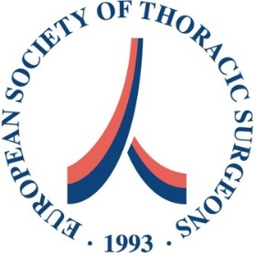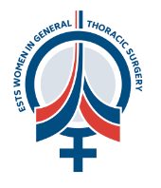

Dear ESTS Member,

We are proud to announce another fellowship opportunity for our early career members.

The ESTS Women in General Thoracic Surgery Committee, supported by Astra-Zeneca, is launching a call for a **clinical research fellowship opportunity** for a woman surgeon.

The candidate will develop a research project based on the ESTS Database on lung cancer (preferably on gender or diversity topics), guided by a mentor in a chosen ESTS accredited institution. The candidate will be involved in the lung cancer care program of this institution as a clinical fellow for 6 months, and will be supported by a €15,000 Grant.

**Requirements for the candidate:**

* Being an ESTS member
* Woman
* Age 40 or less
* Developing a research project **based on the ESTS Database** on lung cancer (with particular focus on gender and other equity related topics) which should be ready to submit within 12 months
* Being able to report about the fellowship and to apply the learned skills in the home institution

**Requirements for the host institution:**

* Being an ESTS accredited center
* Being able to host the candidate for 6 months in the setting of a clinical thoracic oncology unit
* A local staff surgeon agreeing to supervise the project together with a WGTS committee member

**Application documents**

* Short CV candidate
* Description of the project, including brief details on the Host institution (max 2 pages A4)
* Letter of recommendation by the head of the department of the potential host institution, and by the mentor of the project (*can be the same person if they hold both roles*)

Please send your application to Dan Snowdon, ESTS Executive Director ([dsnowdon@ests.org.uk](mailto:dsnowdon@ests.org.uk)) by **16 December 2024**